PO Box 285 ◦ Corvallis, OR 97339  
PO Box 1984 ◦ Albany, OR 97321  
1-800-901-2904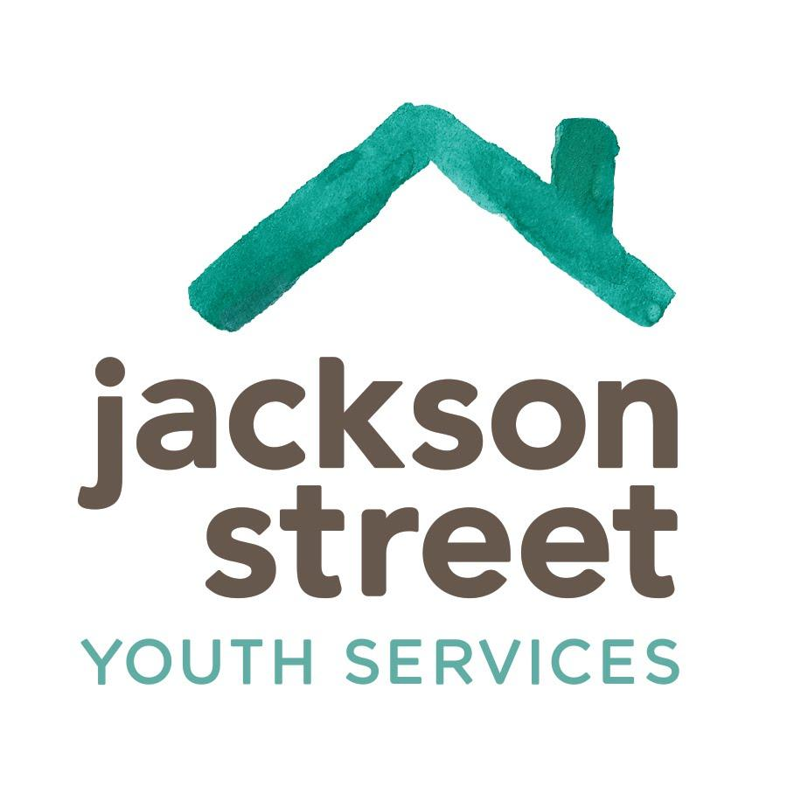

www.jacksonstreet.org

**Outreach Assistant Manager (OAM)**

**Purpose:** To assist in implementing and coordinating a regional (Linn and Benton) Outreach Team to ensure the program and continuum of services are provided in an effective, trauma-informed way to ensure runaway, homeless, and vulnerable youth, in all systems, have the resources and support they need to live more positively.

**RESPONSIBILITIES:**

***Program Management Assistance-***

* Assist Outreach Program Manager (OPM) in the day-to-day operations of the Outreach Program
* Assist OPM in managing and supporting Outreach Team, including training and problem-solving
* Oversee scheduling and supervision of Street Outreach Workers (SOW), Outreach Workers (OW), and Volunteers
* Assign and manage harm reduction caseload, in collaboration with OPM
* Provide on-call coverage (to support Outreach Team), including weekends, as requested by OPM
* Maintain knowledge and understanding of organizational continuum of care
* Make appropriate referrals to internal shelter and housing programs, case management, mental health, and life skills services
* Assist in connecting youth to organizational services or other brief contact services, using harm reduction best practices
* Support with the coordinating and matching of volunteers to youth and projects in various services within the Outreach Team
* Provide access to basic need resources and referrals for community services
* Conduct crisis intervention and collaborative problem solving, as needed
* Help maintain and implement all Jackson Street policies, procedures, and Memoranda of Understanding/Contracts
* Complete semi-monthly supply orders
* Complete Foodshare orders, pick-ups, and reporting

***Youth Service Center and Alley Drop-In Site Support-***

* Design drop-in programming, in collaboration with OPM
* Maintain weekly shifts in the drop-in and provide relief/coverage to other staff as needed
* Support transportation needs for groups and harm reduction clients
* Help maintain physical appearance of sites

***Other-***

* Collaborate with fellow Outreach staff and colleagues from across the continuum of programs to establish and maintain consistent and high-quality services to all youth and young adults served, such as harm reduction, case management, housing, etc.
* Maintain a working relationship with colleagues, program partners, volunteers, and interns and be a role model in terms of professional behavior, communication, conflict resolution, problem-solving, boundaries, etc.
* Attend and participate in all required meetings
* Participate in continued education, certification, and professional development consistently
* Build and maintain relationships with community partners provident street outreach-related services
* Attend street outreach-related community meetings
* Train to work in overnight shelters and fill in for Youth Advocate shifts at overnight shelters for minors, to maintain their 24-hour services, as needed, which may include overnight
* Perform other duties and tasks as assigned
* This position reports to the Outreach Program Manager

**QUALIFICATIONS:**

* ***Required-*** 
  + ***Bachelor’s degree in human services or related field --OR-- 2+* years experience working with runaway & homeless youth (RHY) or youth in crisis**
  + Certification in first aid, CPR, and Oregon food handler's card within 30 days of hire
  + Ability to pass a criminal history and abuse record check
  + Ability to maintain an acceptable driving record, valid driver’s license, automobile insurance, and reliable transportation (use of a personal vehicle throughout Linn, Benton, Lincoln and surrounding counties will be needed and mileage is reimbursed)
  + Ability to successfully complete accurate documentation and administrative tasks
  + Ability and willingness to work flexible hours, including some evenings and weekends to meet the needs of the young adults and program
  + Ability to work effectively both independently and as a member of an integrated team, relate effectively with young adults, family, colleagues, community members, and referral sources in a flexible, sometimes stressful, unstructured work environment
  + Ability to demonstrate cultural sensitivity and work with people from diverse cultural backgrounds, maintain confidentiality, engage in respectful and collaborative problem solving, and present with professional appearance appropriate to the position
* ***Preferred-***
  + Bilingual in Spanish & English and/or Multicultural
  + Supervisory experience
  + Experience working with community partners and social service agencies
  + Possess an understanding and knowledge of adolescent developmental issues, evidence-based practices, and alternative solution-focused case management approaches to address objectives

**PAY & BENEFITS:** Salary starts at $48,027/year ($23.09/hour equivalent), plus $1,040/year ($0.50/hour equiv.) if bilingual in Spanish & English. Benefits include paid time off and holidays, employer-paid medical and dental insurance, voluntary vision insurance, Oregon Saves retirement plan, Employee Assistance Program (EAP), and discounted products and services.

*Jackson Street helps youth 24/7/365*